**TERANG BOWLING CLUB**

a sporting section of the

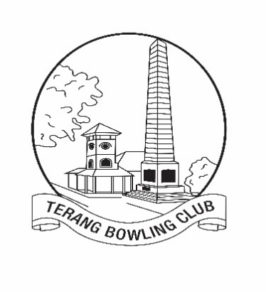TERANG CLUB Inc. #A0009418L

|  |  |  |  |
| --- | --- | --- | --- |
| High St Terang. 3264  Established 1911  Club phone: (03) 55921050  Website: <http://terang.bowls.com.au>  A.B.N. 1209 884 3628 |  | President: Graeme Downie  Phone: 0409 215 828  Email: graeme.c.downie@gmail.com  Secretary: John Gherashe  Phone: 55927228 or 0439935846  Email: [gherashe@westvic.com.**au**](mailto:gherashe@westvic.com.au) | |
|  |  |  |

**2024 - 25 Club Sponsorship**

To:

The Business Owner/Manager,

I am sending this letter to you in the hope that you will once again be an active supporter of our Club and continue with your much valued sponsorship for the upcoming 2024-25 bowls season.

One of the charter goals of the **Terang Bowling Club** is to “**keep our club progressing in its service to the Terang and District community**.”

We believe that the 2024-25 **Corporate Cup** is a prime example of this service, in that it provides a great social and sporting event for over **110 players** each week, for 6 weeks, with the vast majority of the players being non-bowling club members. We also run an **Australia Day tournament**, **the Margaret Sumner Memorial Fours**, **Monthly Triples** during the summer, **Friday bowls** during the winter, as well as our 7 **Pennant teams** and an **Over 60s Tuesday’s Social Pennant team.**

Your sponsorship will gain exposure across a wide area. Teams from **Port Fairy, Warrnambool, Koroit, Timboon, Camperdown, Cobden and Mortlake** regularly compete at our club throughout the bowls season.

As a club, we continue to be progressive and have active **Webpage, Facebook and Instagram sites** **Sponsor links** and recognition are regularly updated on these sites.

Over recent years the Terang Bowling Club has been very active in upgrading its facilities and has also replaced both greens. Without the active support of club sponsors such as yourself, the club could not have achieved such positive outcomes

As a ‘small’ club we rely heavily upon our valued sponsors and we would like to ask your business/company to once again assist our club with sponsorship for the upcoming season.

**See next page for our sponsorship packages for the 2024-25 season**

**Sponsorship packages for the 2024-25 season**

**Major Sponsor: $600 plus**

* Acknowledged in the Club house and at various events throughout the 2023/24 season.
* k to your business webpage and acknowledged on our Club website, Facebook and Instagram (if requested)
* Advertising space either in a shelter (Club view). Highway view signs by negotiation.
* 1300mm x 900mm **sign** **supplied by the sponsor**. (**Star Printing**, is recommended for printing.)

**Event Sponsor: $300 (previously $250)**

* Acknowledged in the Club house and at the event as the **major** **sponsor** of the event

(Year 2023-24)

* Link to your business webpage and acknowledged on our Club website, Facebook and Instagram (if requested)

**Advertising Space Sponsor: $200**

* Advertising space, in a shelter (Club view). Highway view signs by negotiation.

**1300mm x 900mm** **sign supplied by the sponsor**. (Star Printing, is recommended for printing)

**‘Other’ Sponsorship: To value of your choosing**

* Terang Bowls Club also greatly appreciates the supply of goods and/or services such as vouchers to be given as prizes at different Club events. The voucher suppliers will be acknowledged at the event(s). Please let us know if this type of sponsorship suits you.

Please find attached an invoice based on the level of your previous sponsorship package for the 2023-24 season.

For any questions, or further details, please don’t hesitate to contact either myself, the President or the Secretary. Please let me know of any alterations to contact details, it will be much appreciated in my efforts to have accurate records.

In conclusion, any/all assistance will be greatly appreciated by all at the Terang Bowling Club.

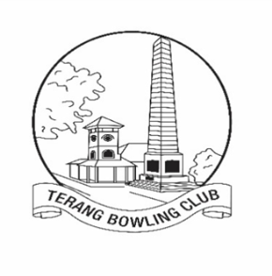

Yours Sincerely

Graham Arkinstall

Ph 0418 377293

Email: [grahamarkinstall@gmail.com](mailto:grahamarkinstall@gmail.com)

Address: 1 Seymour Street, TERANG 3264