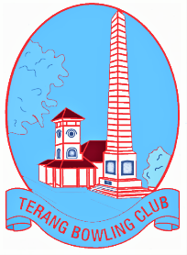
Bowls Green Replacement Update - 17/4/2024
Report prepared by Graeme Downie for the Terang Bowling Club Committee.
Recommendations:
- That the Club purchase 10 safety cones (approx. $14 each) to be used to close rinks.
- That all members are made aware of the appropriate use of, and care for our greens.
- A Maintenance Diary will be kept detailing any work carried out on the Greens – it is important that this is kept up-to date for warranty purposes. It is important that we follow Berry’s advice on care for the greens.
- Excess synthetic – The club is to deal with this – it is ours – at this stage it is for sale $50 a roll. ^ rolls in B Green shelter have been sold.
- An issues book is in the office where members can note any issues or concerns with the playing surfaces. This will be important if any areas need maintenance Or if there are issues with the surface that need rectifying.
- There are 4 attachments after the “Timeline of Work”. – It is recommended that all committee members read these.
Attachment 1 - AFTERCARE AND MAINTENANCE - GUIDELINES FOR SYNTHETIC GREENS
Attachment 2 - ARTIFICIAL DEVICES POLICY
Attachment 3 – Warranty for Greens.
Attachment 4 – Greens Protection Policy.
Update of Greens
Regular updates and photos have been put on our Website and Facebook page to keep members informed.
B Green – Pro Master “Super Plus”
B Green is ready for use and is now back under the Bowling Club’s control. Final marking of lines and installation of hand rails is to be completed over the next few weeks by our grounds committee.
A “come and try” day was held on the 12/4/2024 with 24 players testing out the surface, reports from members were positive and after a few trial ends, most members were achieving good results.
A number of members have been using B Green for practice. Members should use different rinks (including ditch rinks)
Friday Winter Bowls will commence on the 19/4/2024 – starting at 12:30 (names in by 12 noon)
Use of B Green
Please use different rinks and direction as we need all areas played on. NO dumping or DROPPING of bowls on the surface.
A Green – Pro Master Ultra Cool Plus
Whilst it is disappointing that A Green is not ready for handover, the majority of work is completed. Surface and surrounds have been laid and only requires final brushing and rolling. The hold up has been the weather and waiting for the sand and surface to dry sufficiently enough to continue work. Berry’s and I are aware of the frustration, but agree that we don’t need to rush the process. At this stage final work will take place early August or before if possible. This involves final grooming and rolling
Thanks to everyone involved in achieving a great result for the club and a playing surface that will provide years of service. Particular thanks to Darren, Noel, Barry and Erle for there “behind the scene” contributions.
------------------------------------------------------------------------------------------
Timeline of work.

15/4/2024 - Update

A Green work continues.

Playing area Surface has been laid and sand applied with initial brushing and grooming completed. Bank and ditch synthetic grass (terracotta) has been installed. Damp/wet weather has hampered final brushing and rolling. It has been agreed that this can be completed early August (or before if weather is suitable)

B Green

Handover of B Green. A meeting with Tony, Darren, Noel and Graeme was held to go through ongoing care and maintenance. Key points. Brushing of green with supplied groomers to take place on a regular basis once every one to 2 weeks or as required to keep green free of debris/leaves/etc. Ditches to be kept from of leaf litter. At this stage no need for further rolling or watering. General play and use will benefit the surface. Green is running at around 12 – 13 seconds and should improve with use. Note any issues/concerns and record. Keep a diary of work on greens.

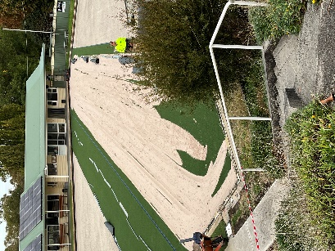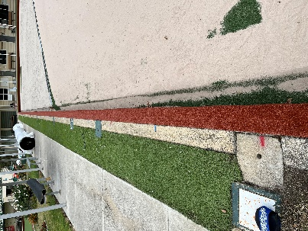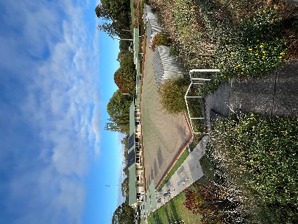

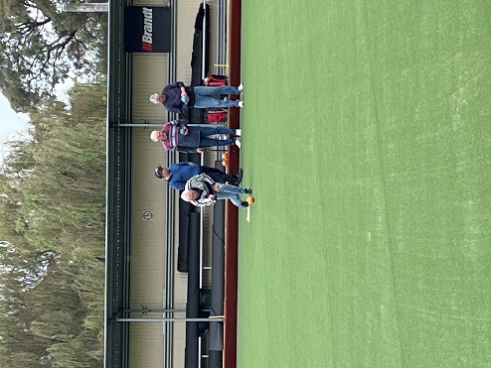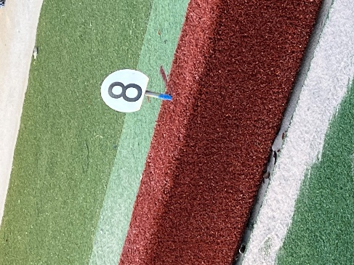

8/4/2024
The team from Berry’s have been working on both greens and all is progressing well.
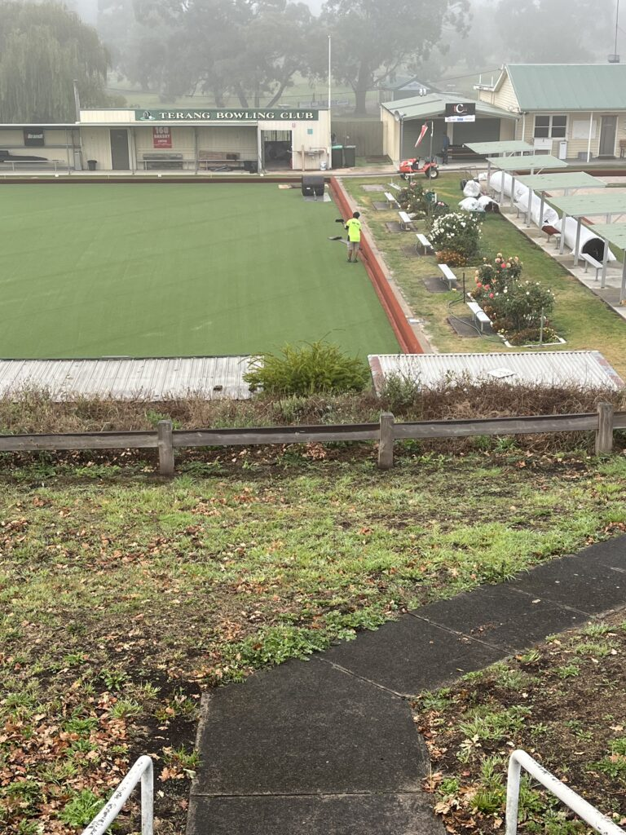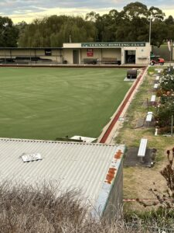
B Green – Grooming and rolling has continued over the last week and the surface is responding well. Rink walls have been covered and ditch mats laid. The green is now ready for test bowling and members can go and have a bowl – please use different rinks and direction as we need all areas played on. NO dumping or DROPPING of bowls on the surface. Berry’s are still responsible for the work area, please ask before using the green. Rink markers are back in place (north/south)
A Green – the 1st rolls of matting have been laid and covered with sand, banks have been covered with terracotta matting. Work will continue this week – weather permitting. Please stay off A Green until further notice.
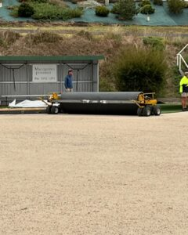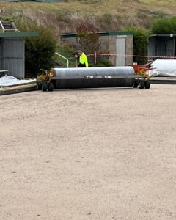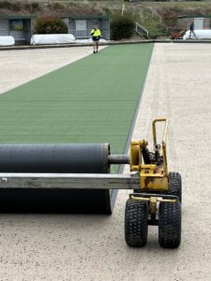
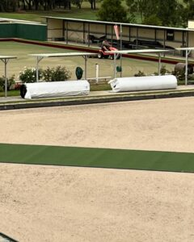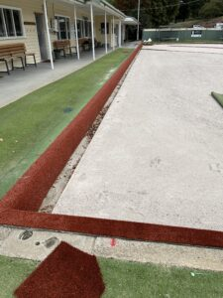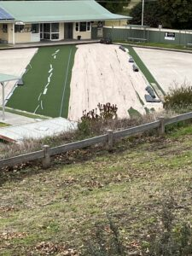

24/3/2024
New Green update. BOTH Greens remain CLOSED, please stay off both surfaces.
Work continues on B Green, with seams glued and sand being spread and worked in. It is hoped that B Green will be completed by the end of next week. Surface laying on A Green will commence after Easter and should be completed by mid April.
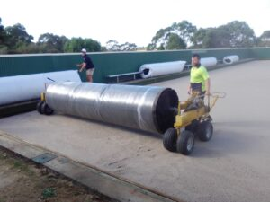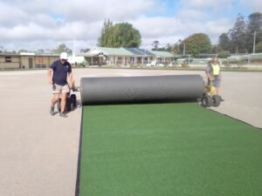
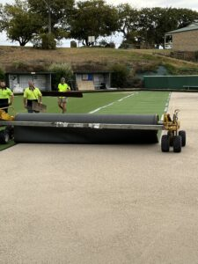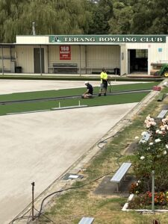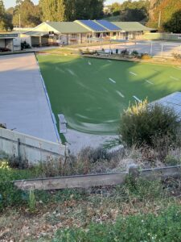

19/3/2024
Work on the laying of the new B Green surface commenced last week and is progressing well. Tony and the team have put down the 1st runs of material and are pleased with the result. Work on B Green will continue this week and should be finished early next week. Work will then start on A Green.

3/1/2024 – Days 3 and 4
Work on preparing the bases of A and B greens progressed well, with both greens now leveled and prepared for the laying of our new surfaces. Thanks to Bill and his team who ensured a great result as both surfaces look amazing.
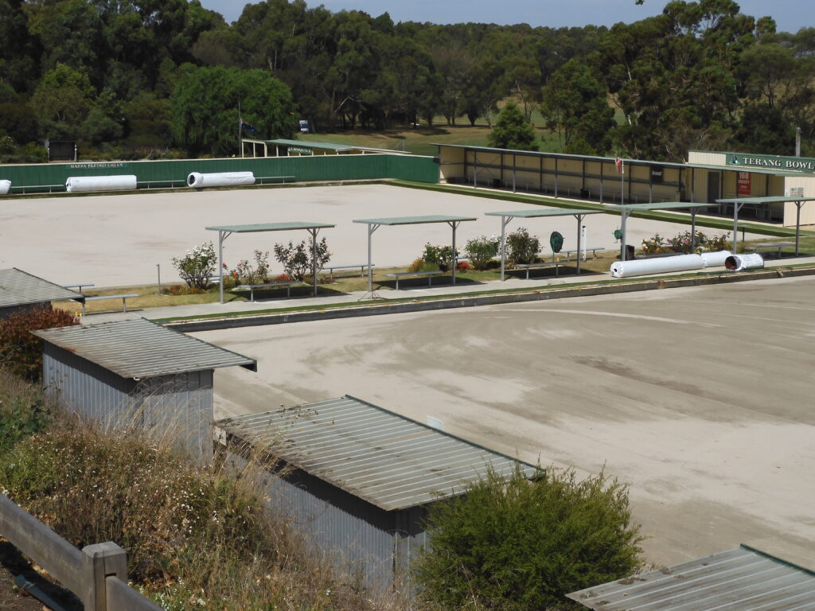
It was terrific that the Club was able to help out some of our community members who will make good use of the old surfaces. B Green has gone to a good home to be used as garden edging and most of A Green went to the Timboon Recreation Reserve to be used around their playground area. A few of our members will also use some of A Green around their homes.
We now let the surfaces settle and work will commence on laying the new surfaces after the long weekend.
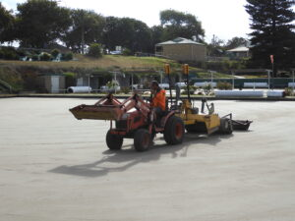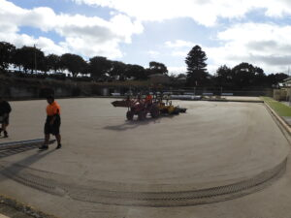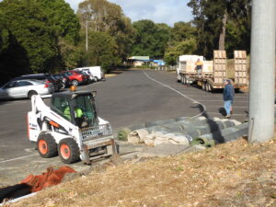
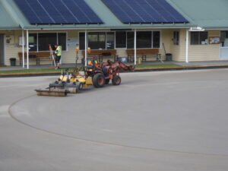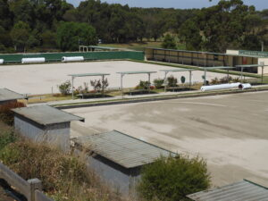
27/2/2024
“A Green” surface was removed today and work commenced on grading and rolling the surfaces.
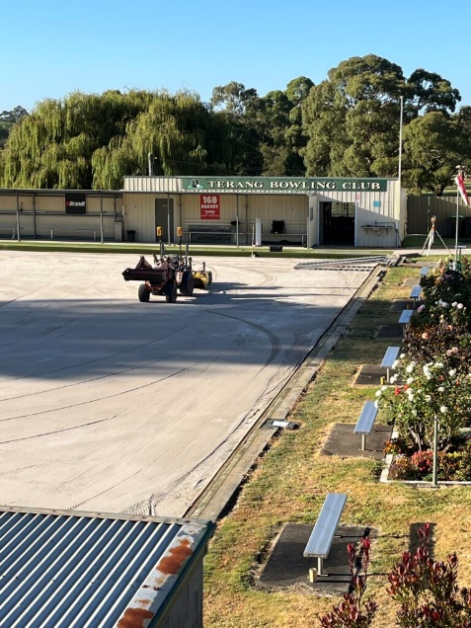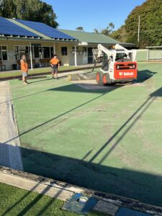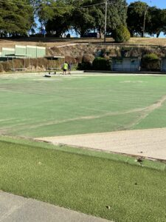
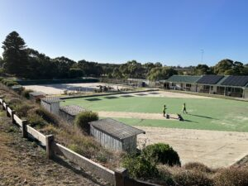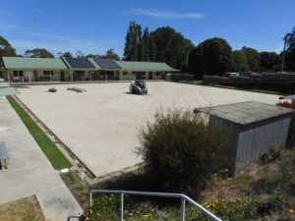
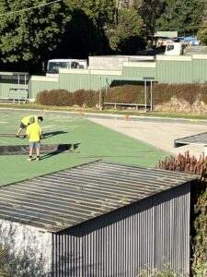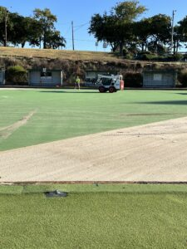
Edging and leveling work was completed on B Green and new surface rolls were delivered. Another great day’s work by Bill and his team.

26/2/2024 – Day 1
An early start for Bill and his team from Berry Bowling Systems. Day 1 saw the setting up in readiness for the removal of B green’s old surface, by the end of the day this was completed and surface preparation was commenced. Thanks to our grounds committee and volunteers who ensured all pre work was completed.
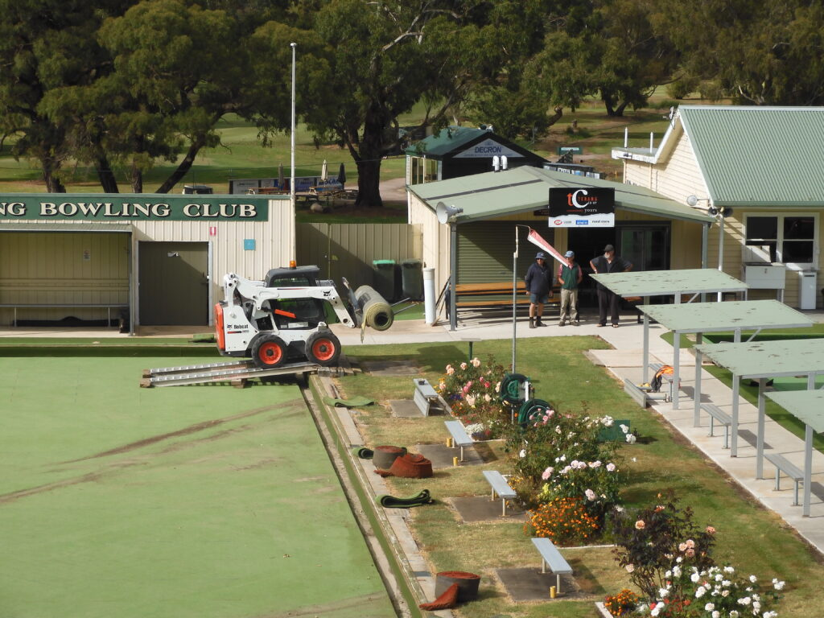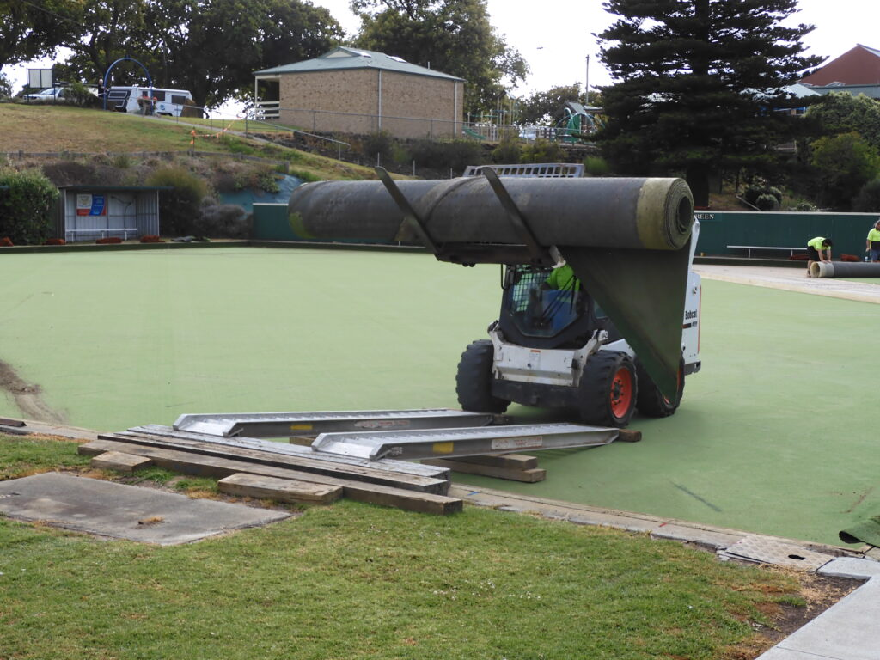
1st roll removed.

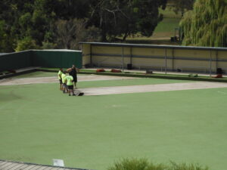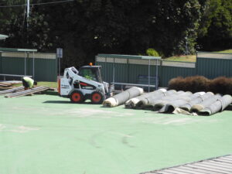

B Green surface preparation
- 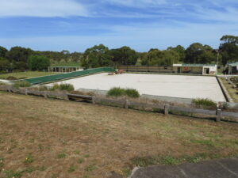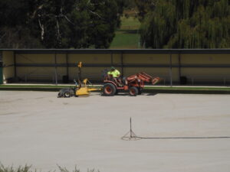

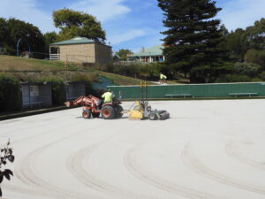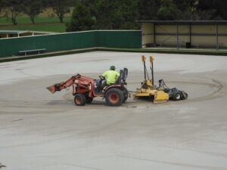

Member information
Please note that the green’s areas will be handed over to Berry’s for the duration of the work. Members are asked to stay off the surfaces from Monday (26/2/2024) until further notice and are advised that while the works are being carried out that the greens area is a construction site and should not be entered without permission. O.H & S protocols will be in place. Any queries should be directed to Graeme or Barry.
23/2/2024 – Grounds committee will complete pre work and prepare area for works to commence.

Timeline for replacement
26/2/2024 – 1/3/2024 – Removal of old surfaces and structural work to bases.
12/3/2024 – 31/3/2024 – New surface to be laid. “B” Green will be 1st and should be available for use mid March (announcement will be made when available)

20/2/2024.
Work on the replacement of our greens will commence on the 26/2/2024.
This is an exciting time for our club and is the result of several years’ work to ensure funding is available. Support from the Corangamite Shire and an infrastructure grant and assistance from Berry Bowling Systems has enabled us to replace both greens. Our committee has also worked hard to ensure that we have the necessary funds to complete the work which will ensure our clubs future for the next 20 years.

Attachment 1.

From Bowls Australia Publication
CHAPTER 10
AFTERCARE AND MAINTENANCE
GUIDELINES FOR SYNTHETIC GREENS
10.3 BASIC MAINTENANCE
10.3.1 Watering
A tufted sand-filled green is likely to need watering to maintain the sand base moisture at the correct level and in turn to maintain uniform green speed. A light sprinkling of a few minutes should be sufficient. Fully damper the surface but avoid over watering (flooding).
10.3.2 Rolling (applicable to sand-filled surfaces)
Rolling should only be done at the direction of the installer. Excessive rolling has the potential to increase wear, alter speed and slow down drainage.
10.3.3 Grooming (applicable to sand-filled surfaces)
Correct grooming helps to: maintain the surface drainage, maintain the correct sand level, open up the synthetic pile to reduce compaction, and remove dead algae and moss. The power brush should be set to penetrate to a depth of about 2 or 3mm into the synthetic surface.
Grooming would generally be carried out monthly or as recommended by the surface supplier.
It is recommended to purchase a leaf blower to keep the green clear of leaves.
10.3.4 Weed/moss/algae control
Control algae and moss before the growth gets out of hand. The treatment procedure usually involves spraying with an approved chemical, as recommended by the surface supplier, then leave until the surface is dry. The surface should then be groomed with the power brush. Small areas can be groomed with a stiff yard broom.
10.4 HEAVY EQUIPMENT
Surfaces can be indented and therefore damaged by heavy or sharp objects standing or dropped on the green. Any such equipment that is required to be placed on the surface should be fitted with pads or boards placed under the legs to spread the load (for example, compressors or scissor hoists for adjusting lights).
Prohibit any narrow and small (less than 50mm diameter) wheeled implements from going on the green, such as roller skates, skateboards, bicycles and, in some cases wheelchairs, that may do damage to the green. Check with the supplier’s warranty for exclusions.
10.5 PLANTINGS
Avoid planting shrubs, climbers or trees near the green. Their roots may disturb the green’s surface, and leaves can create additional maintenance.
Shrubs, trees and hedges that must be planted close to the green should be carefully chosen to avoid roots getting under and into the green. A root barrier should be installed in cases where aggressive rooting species have been planted nearby.
10.6 VANDALISM
Bowling clubs who install synthetic greens should be aware of the risks associated with vandalism. Vandalism can be reduced by the use of security fencing, motion detector lighting systems, alarms and security checks.
Avoid having heavy but moveable objects, such as chairs and signs, left lying around the green, as these could be used as missiles. Such objects should be bolted down or locked away after each day’s play.
Chemicals such as spray paint are extremely hard to remove from synthetic turf, as most of the solvents required to remove paint can also damage the surface.
It is recommended that the bowling club contacts the installer prior to carrying out vandal repairs.
Vandalism repairs should be done by the installer and vandalism is not usually covered in the installer’s warranty.

Attachment 2
ARTIFICIAL DEVICES POLICY
Related Polices: Greens Policy.
Responsible Officers: BA CEO;
National Officiating Advisory Group.
Policies are
binding on all Members.
20.1.2 The CEO shall bring to the notice of the Board and Members all Policies and any formulation, interpretation, amendment, alteration and repeal
of them. Member States are obliged to draw such notices to the attention of Members in their States. Notices are binding upon all Members.
20.1.3 All Policies and regulations of the Company in force at the date of the approval of this Constitution insofar as such policies and regulations are
not inconsistent with, or have been replaced by this Constitution, shall continue in force under this Constitution.
1. PRINCIPLE
The Bowls Australia philosophy is to allow access to our sport to as many participants as possible and ensure an inclusive atmosphere from club to elite level. We must also ensure that bowlers (regardless of any requirement of a wheelchair or artificial device) must not damage the playing surface during play.
2. POLICY
2.1 The Laws of the Sport of Bowls Crystal Mark 3rd Edition, Version 3.1, April 2019
Law 41.1 under the heading of ‘Players with disabilities’ states that “Wheelchairs should be of a type approved by both World Bowls and the Governing Body for wheelchair bowlers in the country in which the player is playing” (in this case Bowls
Australia in conjunction with Wheelchair Sports Australia Lawn Bowls).
2.2 Law 41.8 states that Member National Authorities can approve the use of artificial devices for delivering the jack or bowl such as a Bowlers Arm.
3. SPECIFICATIONS
3.1 Wheelchairs
3.1.1 The large and usually rear tires (pneumatic or soft rubber slicks), must have a minimum width of 45mm. Tires must be smooth “slicks” or inverted tread tires.
3.1.2 The most suitable tires for the small or front wheels are 200mm x 50mm with a pneumatic tire or soft rubber “slicks”.
3.1.3 Castors, made of nylon or polyurethane are becoming increasingly popular and can also be used for front wheels. The recommended width of these should be a minimum of 75mm. It is a requirement that the edges, if sharp, must be rounded off.
3.1.4 If there are any doubts about tire tread, duct tape can be placed over the tire to provide a smoother surface as a temporary or precautionary measure.
3.1.5 The above guidelines are intended for use in all conditions, however in the case of particularly wet greens or other unusual circumstances, consultation and a common sense approach between the wheelchair user and club administrator or greenkeeper is appropriate. To further ensure there is no undue damage to the green, players should ensure a wide circle is taken when turning their chair on the green.
In the event of a dispute, the Greenkeeper and or Controlling Body / Tournament Director / relevant Official shall be the final decision maker.
3.1.6 The use of an electric wheelchair encompasses the above guidelines and measurements, with the additional consideration of the weight of the chair.
This is of particular importance for the care of the surface where the green is wet or experiencing another unusual circumstance.
Artificial Devices Policy | Page 2 of 3
4.1 Walking Frames
4.1.1 Walking frames can be used provided the frame does not cause damage to the green. To eliminate damage that may be caused to the green, the frame must
comply with the following:
4.1.1.1 Preferably wheels of 45mm and pneumatic as applied to wheelchairs or wide wheels that are smooth and without tread.
4.1.1.2 If the frame has “feet”, each one must have its own base covered with rubber or similar material. The base should measure at least 76mm across.
4.1.2 Players are not to sit on their frames while on the green unless each “foot” and wheel complies with the specifications above.
5.1 Bowlers Arms
5.1.1 “Bowlers Arms” have been successfully introduced into the game to allow persons with a physical restriction or impairment that would otherwise prevent them from playing the game the opportunity to play, or continue to play, bowls. There are various types of bowlers arms approved for use in Australia.
5.1.1.1 Each device is manufactured in several lengths and release mechanisms.
Only approved arms (with a BA logo as part of the National Merchandising Program) can be used in Australia. Modifications are not permitted (with exception to the rubber grip on the bottom of the arm which may need to be replaced as it wears out.). For a list of approved bowlers arms refer to the Bowls Australia website at http://www.bowlsaustralia.com.au/Club-Assist/Approved-bowlers-arms.
5.1.2 If a player is using a bowlers arm that is not approved, the player becomes a defaulting player as per C.2 (definitions) and will forfeit the game as per C.10 (definitions).
5.1.3 A player may use any number of approved bowlers arms during trial ends for suitability. Once a game has commenced, the designated brand or style of bowlers arm chosen by the player must stay the same during the match.
5.1.4 Whenever a player commences using an approved bowlers arm in a game, the player must use it for the remainder of that game. This does not apply to the rolling of the jack, which can be rolled either by hand or by a bowlers arm.
5.1.5 A player cannot alter/change the brand or style of approved bowlers arm during the course of a game except in such circumstances where the device is rendered unplayable and in this instance, the player may change to another approved brand or style of bowlers arm on approval by the umpire or controlling body.
5.1.6 Challenge on appeal to an umpire or controlling body regarding a bowlers arm could occur before the trial ends or up to 10 minutes after a game (but not during the game) as similar to Law 52.4.3 and 52.4.4. 2.

Attachment 3
Greens WARRANTY
1. The surfaces will achieve the standard required by the Local authority for pennantplay and is playable in both directions.
2. The manufacturer warrants the surfaces against UV degradation for a period of 7 years.
3. Berry Bowling Systems Pty Ltd warrant that the surfaces will continue to meet conditions for pennant play as presently applying, for a period of two years, subject to the application of our approved maintenance procedures, even use across the rinks and excluding any abnormal or seasonal factors (likely to induce stresses beyond that of the game of bowls)"
4. No responsibility can be taken in regard to any sub-base movement.
5. Any works carried out on this green by any organisation or individual, without the written authority of Berry Bowling Systems Pty Ltd will void any warranties provided by Berry Bowling Systems Pty Ltd and any of its suppliers and manufacturers.
6. For this warranty to remain valid, the following conditions are to be observed.
(a) That the surfaces are cleaned and maintained in strict accordance with the maintenance guidelines provided at installation"
(b) That the surfaces are used only and solely for the purpose for which it is designed and installed.
{c) That the surfaces are not willfully or maliciously damaged.
{d) That the surfaces be subject to normal wear and tear.
(e) That only appropriate footwear and sports equipment is used.
(f) That the Club maintain a detailed Maintenance Record.

Attachment 4
Bowls Australia – Greens Protection Policy
1. PREAMBLE AND RATIONALE
1.1 This Policy acknowledges that greens are the core material asset of clubs and inherently expensive to repair and replace. This applies to both grass and artificial surfaces.
1.2 This Policy also acknowledges that through remedial practices the vast majority of bowlers should be able to continue to enjoy and compete in bowls and that bowls will continue to be a sport for life.
2. GUIDELINES
2.1 According to the Laws of the Sport, Crystal Mark 3rd Edition, Version 3.1, April 2019, the process for a player who is causing undue damage to the green is as follows:
2.1.1 If by observation, the Controlling Body or deputised representative, considers a player is causing damage to a green, the player will be warned;
2.1.2 The skip and manager must be alerted to the warning given to the player;
2.1.3 If in the opinion of the Controlling Body the player continues to damage the green, the player must be required to retire from the game but may be allowed a substitute player as per DR2.4;
2.1.4 If the player fails to leave the green the player will be considered to be a defaulting player and forfeit the game to their opponent as per Law C2 and Law
C10, and no substitute will be allowed.
2.1.5 The Controlling Body must advise the home club of the player concerned so that appropriate assistance can be offered to the player.
2.2 Clubs have an obligation to assist bowlers to remedy the action or activity that is causing damage.
2.3 To assist a player who is damaging the green, the following should be considered:
• Attempt to understand how or why the player is causing damage to the green;
• Ask the club coach to contact the player and provide some coaching advice;
• Modify the player’s delivery;
• Discuss with the player options such as obtaining approval to use a bowlers arm;
• Use a ground sheet when delivering a bowl;
• Use a dump mat.

