TERANG BOWLING CLUB
a sporting section of the
TERANG CLUB Inc. #A0009418L
High St Terang. 3264  P.O. Box 126  Established 1911  Club phone: (03) 55921050  Website: http://terang.bowls.com.au  A.B.N. 1209 884 3628 | 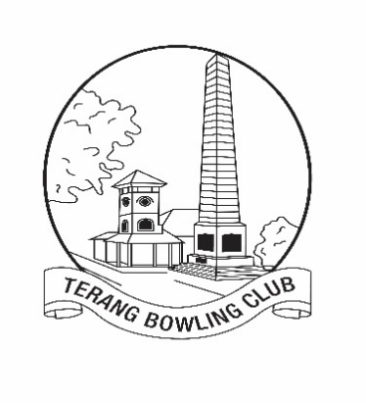 | President: Barry Stonehouse  Phone: 0429809710  Email: bstonehouse4@gmail.com  Secretary: John Gherashe  Phone: 55927228 or 0439935846  Email: gherashe@westvic.com.au
2023/24 Club Sponsorship

One of the charter goals of the Terang Bowling Club is to “keep our club progressing in its service to the Terang and District community.”

We believe that the 2022, Corporate Cup is a prime example of this service, in that it provides a great social and sporting event for over 110 players each week, for 6 weeks, with the vast majority of the players being non-bowling club members. We also ran an Australia Day tournament, Ladies Invitation Day, monthly triples during the summer, Friday bowls during the winter, as well as our 7 pennant teams and an Over 60s team.

In 2019, we conducted: “Bowling with Babies”, “Jack Attack” for our local school, a Year 9 Bowls program and Barefoot Bowls for a local scout group. These programs have been developed to support local community groups and are usually run by volunteers at no cost to the participants.

Your sponsorship would gain exposure across a wide area. Teams from Port Fairy, Warrnambool, Koroit, Timboon, Camperdown, Cobden and Mortlake regularly compete at our club throughout the bowls season.
As a club, we continue to progress and have recently setup our own Webpage.
** Sponsor links and recognition are placed on this site.

As a business group, you would be well aware that such a venture requires an adequate cash flow. The cost of a synthetic green is significant (2022 estimated cost $160 000), with a life expectancy of 12 years. Our ‘A’ green is approaching this age. We are saving for a replacement green in 1– 2 years time, hopefully, but this is a big financial commitment.

We have also been updating our facilities: new shelter on ‘B’ green, upgraded surface on the cement path in front of the clubhouse, a toilet near ‘B’ green, planting out the roadside bank and installing water coolers.

We are pleased with the development of our outdoor BBQ area, and thank our generous sponsors for their support.

As a ‘small’ club we rely upon our valued sponsors and we would like to ask your company if they can help us out with some sponsorship:

See Over for new sponsorship packages for our 2023-2024 season

Following are examples of our sponsor packages:

Major Sponsor $600
- Acknowledged in the Club house and at various events throughout the 2020/21season.
- Link to your business webpage and acknowledged on our Club website (if requested)
- Advertising space either in a shelter (Club view) Highway view signs by negotiation.
- 1300mm x 900mm sign supplied by the sponsor. (Star Printing, is recommended for printing.)

Event Sponsor $250
- Acknowledged in the Club house and at the event as the major sponsor of the event
(Year 2020-2021)
- Link to your business webpage and acknowledged on our Club website (if requested)

Advertising Space $200 or ($550 for 3 years)
- advertising space, in a shelter (Club view) Highway view signs by negotiation.
1300mm x 900mm sign supplied by the sponsor. (Star Printing, is recommended for printing)

Support for Club Improvements

We currently have 2 major improvement projects:
- Replacement of our greens – Approx. cost $320000.
- “Lighting UP” A Green – Approx cost $80000.

Whilst we would not be looking for the total amount, we would acknowledge all significant contributions towards either project. (This would include appropriate signage, recognition in and around the club and on the website as deemed appropriate)

Should you be able to help, please contact us so that we can discuss a sponsorship package that would benefit us all.

Any assistance will be greatly appreciated.

For further details please contact the President, Secretary or
Graeme Downie. Ph: 0409215828 Email: graeme.c.downie@gmail.com
