TERANG BOWLING CLUB
The Club was established in 1911 and has a proud history of developing and upgrading the facilities to meet the needs of the community.

An active committee and committed volunteers are the cornerstone of our club, ensuring that our greens and facilities are well looked after. 2021/22 saw the development of our new outdoor kitchen area and the introduction of new uniforms.
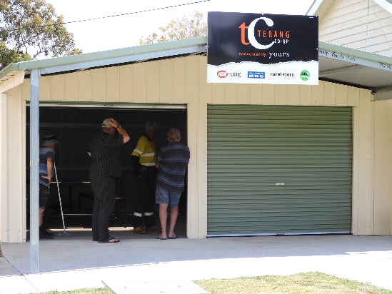
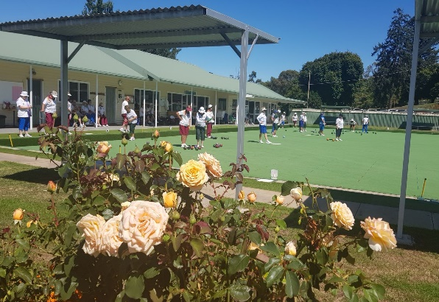

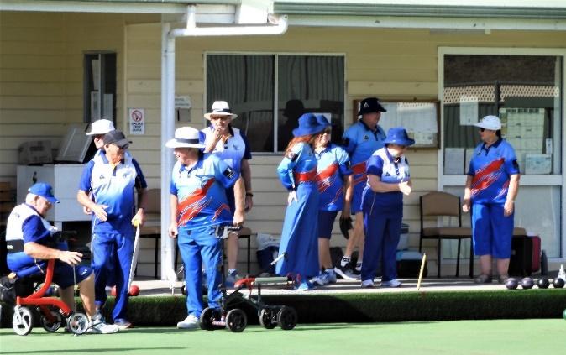
New outdoor BBQ area 2021/22

Our club supports our community and promotes a healthy lifestyle for all ages. It provides significant social, physical and mental health benefits for our members and the broader community.
- 80 members, 6 pennant teams and an Over 60s team.
- Teams from Port Fairy, Warrnambool, Koroit, Timboon, Camperdown, Cobden, Dunkeld and Mortlake regularly compete at our club.
- Western District Playing Area and West Coast Region events.
- Active Website and Facebook page.
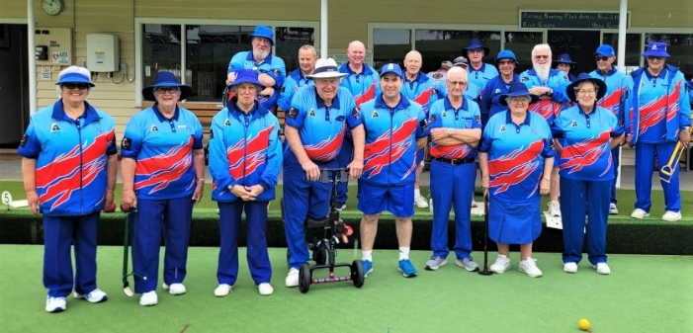

2022 - Terang Corporate Challenge.
- Annual community event providing a great social, wellbeing and sporting event for over 140 players over 6 weeks.
- Teams entered represent many of our local businesses, community groups and surrounding communities of Glenormiston, Noorat, Dixie and Garvoc.
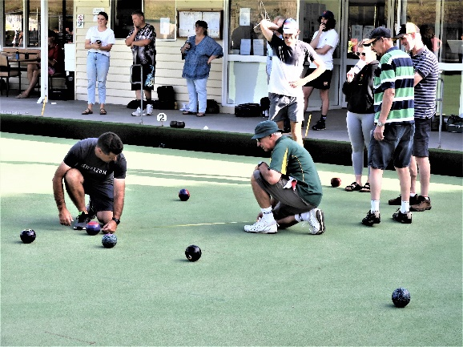
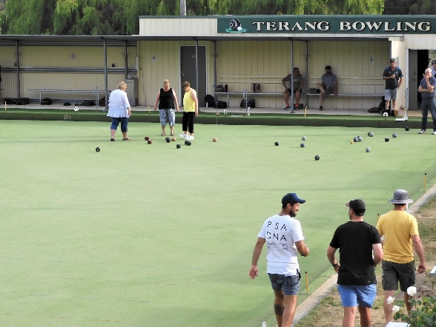

Major Tournaments and Events
- “Kevin Lee” Australia Day tournament. 112 players.
- “Margaret Sumner” Ladies Invitation Day. 80 players.
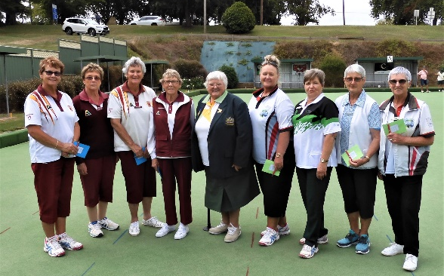
- These tournaments acknowledge the significant contributions of two of our club icons and attracts teams from across the Western District, Melbourne and Geelong.
Margaret Sumner (OAM), with 2022 winners.
Kevin Lee, with 2022 winning teams
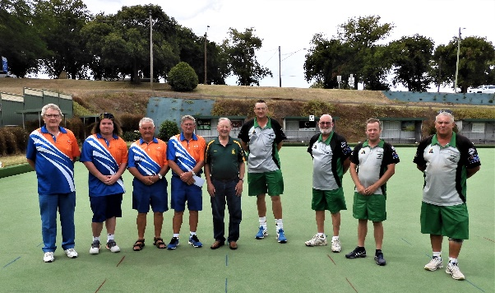

Annual Rotary Day and Hospital Auxiliary events are facilitated by the club and supported by our members. These events assist these two community organisations with their fund raising.
Events:
- Monthly Triples (October- April) Approx. 80 participants each month
- Weekly Friday Bowls (May to September) 20-40 participants each week.
- State and Club events. Varies for each event.
- Social bowls. Varies – around 10 – 20 across a week.
- Team practice sessions. 50- 60 participants weekly during pennant season.

In 2019, we conducted: “Bowling with Babies”, “Jack Attack” for our local school, a Year 9 Bowls program and Barefoot Bowls for a local scout group. DUE TO Covid restrictions we were unable to hold similar events in 2020 and 2021 but are keen to run these and other events in the future.

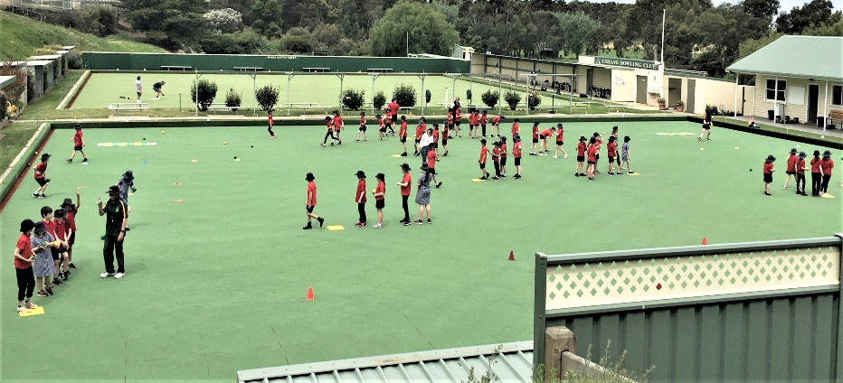
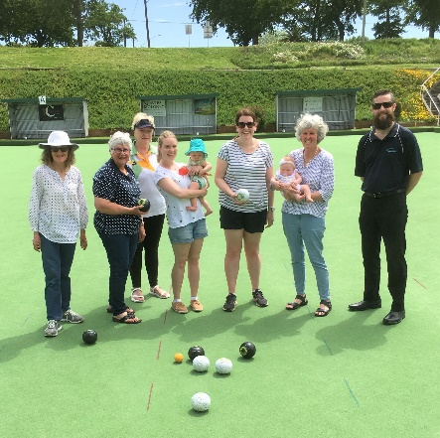
Bowling With Babies, 2019
Terang College – Jack Attack program – 2019.

- Strong community support from our valued sponsors. Our new uniforms were a direct result of the partnership between the Terang Co-op and Crawley’s “The Middle” Hotel.
Our Sponsors

Looking Forward
The Club needs to replace our two synthetic greens and is exploring the addition of lights on our A Green. The replacement of the greens is of vital importance, as without these the club would cease to exist along with the services it provides. The addition of lighting would enhance the Club’s ability to develop a variety of evening events and activities.
Anticipated costs – Green replacement $340000 - $360000.
New Lighting Facilities - $75000 - $80000.

